The Icelandic Route Support Fund
Application Form for Route Support for flights to AEY and EGS
Applicant/Operator name
Billing Address
Route Name
Destination ICAO airport code
Frequency of Year-round operation
Frequency of Seasonal operation
Aircraft Capacity
Start-up date
End date of operation
Aircraft Type | ICAO type designator | IATA type designator
Scheduled | Scheduled time of | Scheduled time of
Timings | Arrival AEY/EGS | Departure AEY/EGS
Monday
Tuesday
Wednesday
Thursday
Friday
Saturday
Sunday

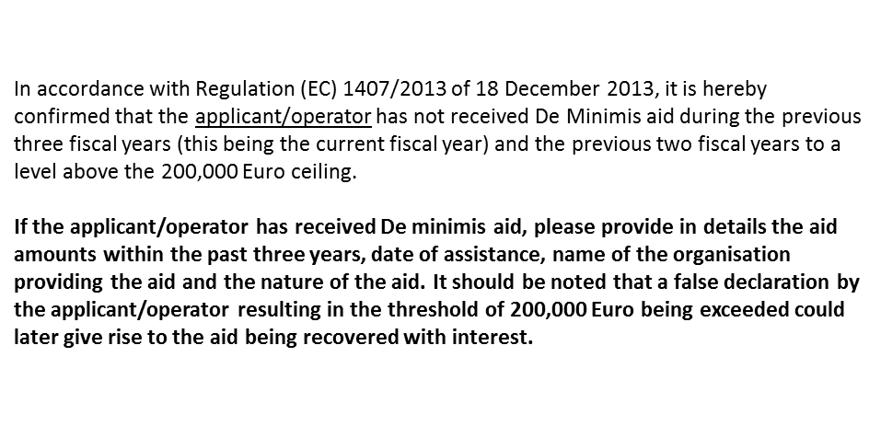
Aid amounts for the past three years
Aid provider
Date of assistance
Nature of the aid

__________________________________________________
Place and date

__________________________________________________
On behalf of the applicant/operator

